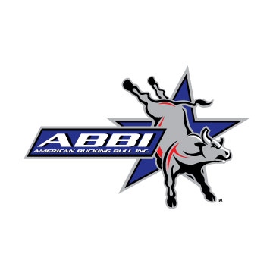**2021 Application for Registration**

**SAMPLES MUST BE INCLUDED WITH APPLICATION.**

**DO NOT SEND SAMPLES IN PLASTIC BAGS. ALL SAMPLES MUST BE ON ABBI SAMPLE CARDS.**

**Name: _____ Member #: 0001 Phone #:____________________________**

**Address: ____ City: State: _______ Zip Code: _____________ ___**

|  |
| --- |
| **Animal registration requires all the information requested on this sheet.** |

|  |  |  |  |  |  |  |  |  |  |  |  |  |
| --- | --- | --- | --- | --- | --- | --- | --- | --- | --- | --- | --- | --- |
| **Date of Birth** | **Sire Name & Reg. Number** | **Dam Name & Reg. Number** | **Animal Name (no profanity/ off-color names)** | **Animal's Brand #** | **Animal Color** | **EID Tag**  **$15 each** | **Super Stakes**  **$25/bull** | **Horns** | **Sex**  **Type Service** | **Original Breeder** | **Office Use** | |
| mo/dy/yr  *\*Required* | *\*Required if registered* | *\*Required if registered* | *\*Required* | *\*Required* | *\*Required* | US S&H: $5.90  Canada: $12.50 | Birth Year Bulls only | Type | *\*Required* | ABBI Breeder # | Registration Number | |
| 1/15/2021 | Sire 1  10000001 | Dam 2  10000002 | Calf 1 | 1 | red | **Y**  **N** | **Y**  **N** | **P**  **H**  **D** | **B C**  **N AI ET** | 0002 |  | |
|  |  |  |  |  |  |  |  |  |  |  |  | |
| 1/10/2021 | Not registered | Not registered | Calf 2 | 2 | black & white paint | **Y**  **N** | **Y**  **N** | **P**  **H**  **D** | **B C**  **N AI ET** | 0001 |  | |
|  |  |  |  |  |  |  |  |  |  |  |  | |
| 1/31/2021 | Sire 3  10000003  Sire 4  10000004 | Dam 5  10000005 | Calf 3 | 3 | white | **Y**  **N** | **Y**  **N** | **P**  **H**  **D** | **B C**  **N AI ET** | 0001 |  | |
|  |  |  |  |  |  |  |  |  |  |  |  | |
| 1/1/2021 | Sire 3  10000003 | Dam 6  10000006  Dam 7  10000007 | Calf 4 | 4 | red brindle | **Y**  **N** | **Y**  **N** | **P**  **H**  **D** | **B C**  **N AI ET** | 0001 |  | |
| Notes: |  |  |  |  |  |  |  |  |  |  |  | Page: |

**All DNA samples submitted and profile created therewith will be considered property of ABBI.**

**Owner’s Signature__________________________________ *Applications Will Not Be Processed Without A Signature.**

**American Bucking Bull Inc.** 101 W. Riverwalk, Pueblo, CO 81003 Phone: 719-242-2747/Fax: 719-242-2746